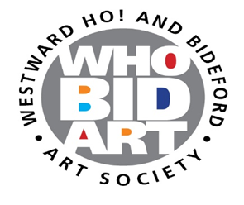
ANNUAL EXHIBITION
GUIDELINES FOR PRESENTATION OF ARTWORKS

Work for inclusion in the WHOBIDARTS’ exhibition is expected to be finished (e.g. mounted and/or framed), in a professional manner. The guidelines below set out what is expected. Presentation of work which does not meet these expectations will not be accepted.
2D works – Paintings (excluding watercolour) and resin works.
- Framing is often subjective, but artists should have in mind the aesthetic they wish to present when choosing framing. Badly chosen or substandard framing can detract from what otherwise might be good work and may affect selection.
- Framing should be solidly constructed without any breaks, split corners or coming apart or any other marks or damage (unless these are integral to the work itself).
- Paintings should be fixed securely in the frame. D-rings and cord should be attached approximately one third down the frame and the cord should be tightly stretched so that when hung from a single point the cord does not show above the frame. See Figure 1. If the D-rings are attached too low the painting will tend to hang badly. Missing D-rings and incorrectly positioned cord will result in the work not being accepted.
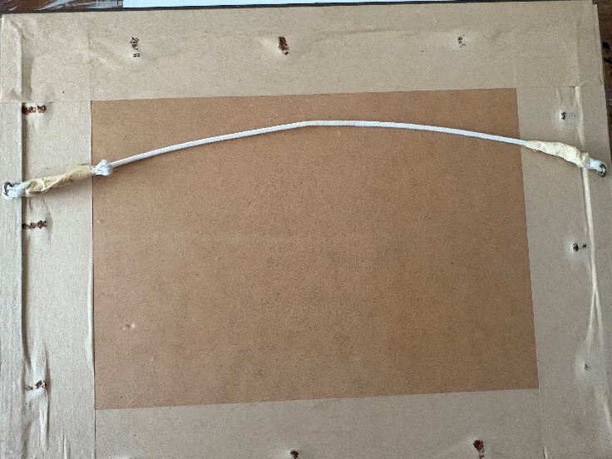
Figure 1

- Unframed paintings are accepted but the sides of the frame should be appropriately finished in white, black or another single colour that complements the work. Where the edges of the painting are part of the work or the work is intended to show the nature of its construction unfinished edges can be accepted.
- Warped unframed works which cannot be hung satisfactorily will not be accepted.
- As above, D-rings and cord should be attached approximately one third down the frame and the cord should be tightly stretched so that, when hung from a single point the cord does not show above the frame.
- Giclée prints of paintings or original print are NOT permitted.
2D works – Drawings (pencil, pastel etc), watercolour paintings, original print works
- In most cases, these works should be presented in appropriate frames behind glass to protect the work. There may be examples of drawing which should be presented differently, and this will be considered by the selection panel.
- Framing construction etc., should be in line with the guidance for 2D works - Paintings. If you are using frames with the type of backs such shown in Figure 2, please ensure the back is finished/taped as shown in Figure 3. This will prevent dust getting behind the backing board and between the glass and the image.

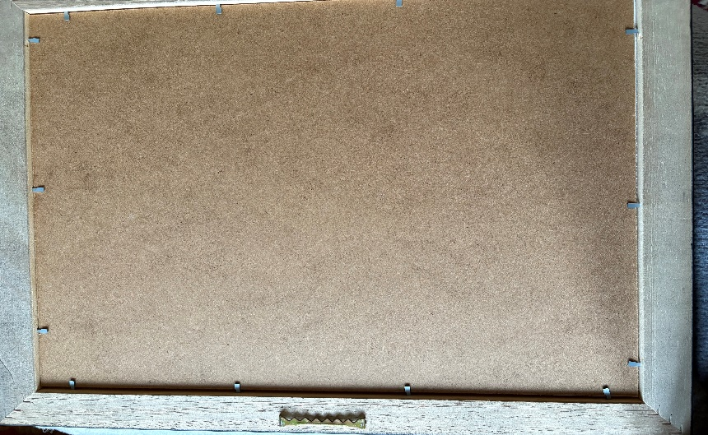
Figure 2

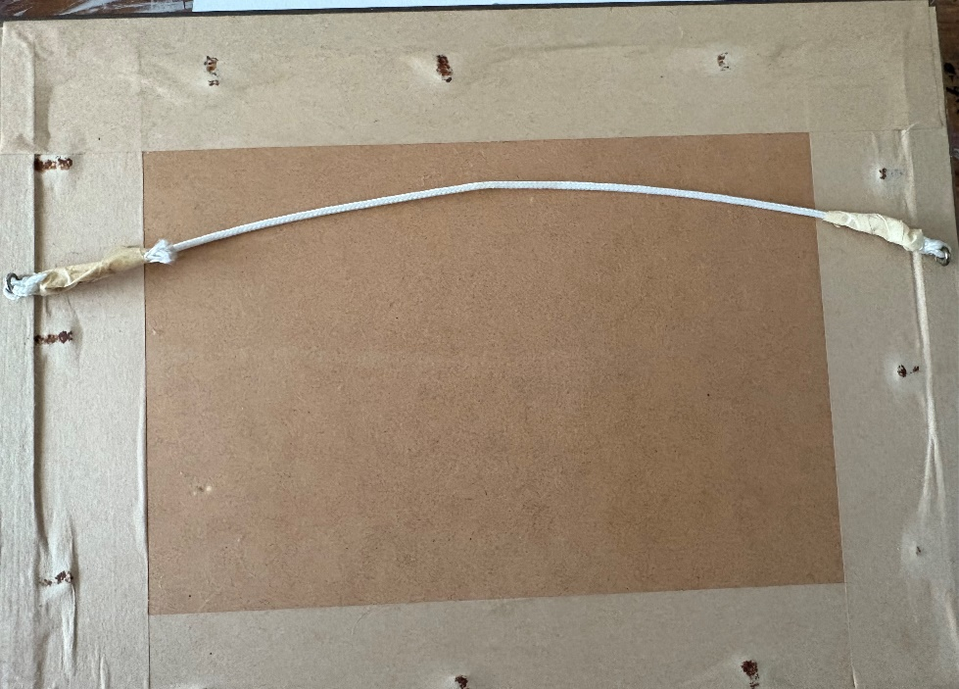
Figure 3
- Clip frames, glass without protective edging and frames using perspex will not be accepted.
- Original print works on paper, where editioned, should be clearly marked with the edition number. Work intended to be part of an unlimited run will not be accepted.
- Where a mount and backing board is used these should be acid free and of archival quality and appropriate for the aesthetic of the work.
- Giclée prints of paintings or original print are NOT permitted.
Photography and digital work
- Photographs or digital work on paper should be presented as per 2D works – Drawings.
- Where the photograph or digital work is presented bonded to a board or metal surface e.g. Dibond and does not need protection, then it must also be presented with D-rings etc., for hanging. Any other form of hanging should be identified at handing in and will be reviewed by the selection panel.
- Photographs and digital works will only be accepted if they are unique/one off works or part of a limited edition and this is indicated clearly on the artist’s entry form and on the work itself.
- The work should be either Giclée or on archival quality photographic papers printed with archival inks. Giclée prints of paintings or original print are NOT permitted.
- Where a mount and backing board is used these should be acid free and of archival quality and appropriate for the aesthetic of the work.
3D works (plinth or floor mounted)
- All 3D works should be of solid construction that does not present a hazard. The work must be stable on its base and stand secure.
- The base of the work should be smooth or suitably covered so as not to damage plinths or other surfaces.
- Any pieces attached to the work should be firmly secured and not able to be removed.
- Any large or heavy pieces of work should be discussed with WHOBIDARTS’ Exhibition Manager before submitting an entry form.
- If any work requires on-site assembly, please discuss with WHOBIDARTS’ Exhibition Manager prior to submitting your entry form.
- Due attention to health and safety should be given and any risks should be identified at the time of submitting your entry form.
3D works (wall mounted)
- Wall mounted 3D works should have secure hanging capable of taking the weight of the work and the hanging system should not be overly complex.
- As far as practicable, the hanging system should not be visible to the viewer.

