
ANNUAL EXHIBITION
THE BURTON AT BIDEFORD
GUIDANCE NOTES AND TERMS

Submitting an entry to take part in the exhibition
1. The exhibition is open to Full/Life Members, Associates of WHOBIDARTS and Non-Members also.
2. The closing date for submitting an entry to take part in the exhibition is midnight on Friday 6 March 2026.
3. Completed entry form to be submitted in an email to susanbrooklynharris@gmail.com.
As an alternative to submitting an entry form you may submit an email to susanbrooklynharris@gmail.com making sure you include the following information:
- Your name
- Contact details (email and phone)
- Details of the work you wish to submit – title, medium and price.
Whether completing an entry form or providing information in the form of an email, please ensure you provide accurate information in relation to work you wish to submit – in particular title of work and price, as no changes will be allowed to this information after the closing date for submission of entries i.e. Friday 6 March.
4. In submitting an entry form you agree -
- to comply with these guidance notes and the guidelines for presentation of artworks, and
- that your contact details may be shared with any person interested in your work, anyone stewarding the exhibition and The Burton.
5. Please DO NOT submit any images of your work with your entry form.
6. Fees for taking part in the exhibition are:
- Life Members – No fee
- Full Members - No fee - PROVIDED THAT the annual subscription fee has been paid*
- Associates - £4 per piece of work entered PROVIDED THAT the annual subscription fee has been paid*
- Non-Members - £10 per piece of work entered.
* If annual subscription fees have not been paid, you will not be eligible to enter for the exhibition.
7. Fees must be paid AT THE TIME OF SUBMITTING YOUR ENTRY FORM, by bank transfer to Westward Ho and Bideford Art Society, Sort Code: 30-90-78 Account no: 00094676, Please use your last name as the reference. If you are not able to make a bank transfer, please contact Susan on susanbrooklynharris@gmail.com to discuss alternative methods of payment.
8. Fees are non-refundable even if any work submitted is not selected for the exhibition.
What can I enter for the exhibition?
9. The number of pieces of work you can submit for selection are:
- Life/Full Members - up to 4 pieces
- Associates - up to 3 pieces
- Non-Members - up to 2 pieces
10. The pieces you submit for selection can be either 2D or 3D or a mix of both 2D and 3D. PLEASE NOTE: work such as jewellery, household/domestic goods e.g. cushions, lampshades, etc., are considered as craft and are not eligible for entry into this exhibition.
11. Whether you are entering 2D, 3D or a mix of both 2D and 3D work, the total area an artist’s work (including frames) can occupy must not exceed 3 sq.m.
Preparing your work for handing in
12. All work must be original and completed within the last 5 years and must not have been shown at any of the Society’s previous exhibitions nor at any other exhibition in Bideford.
13. Work must be submitted in your own name, i.e. no pseudonyms unless you are known professionally by, and exhibit regularly under, a pseudonym.
14. All work submitted must be presented in accordance with ‘Guidelines for presentation of artworks’, a copy of which has been included with these guidance notes.
15. All work must be for sale, clearly priced and allow for the 25% commission (see paragraph 32).
16. Labels for attaching to your work are included with these guidelines for you to print off as many copies as you need. Complete the labels in block capitals making sure the information matches that which you have included in your entry and attach to each piece of work as set out below.
(a) For 2D/framed work, attach one label on the back of the work in the top right-hand corner – see Figure 1.
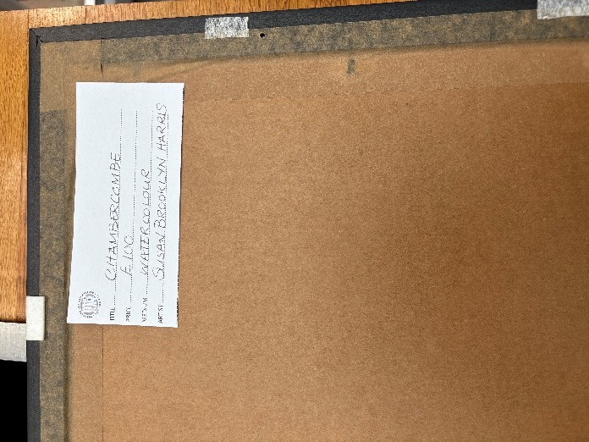
Figure 1
Attach a second label firmly with about 15cm of string so that the label hangs over the front of the work but can be pushed behind the work when cataloguing has been completed – see Figure 2.

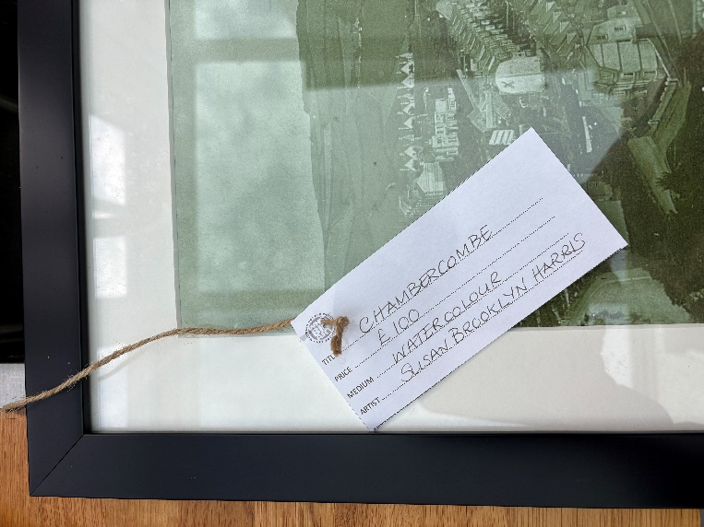
Figure 2
(b) For 3D work, labels should be attached to the work as best and as firmly as possible (preferably the base) so that they can be either removed or pushed out of sight once cataloguing has been completed.
PLEASE MAKE SURE YOU ATTACH THE LABELS TO THE WORK BEFORE YOU COME TO THE BURTON FOR HANDING IN. IF YOUR WORK IS NOT LABELLED AS REQUIRED, YOUR WORK WILL NOT BE ACCEPTED.
In addition to the required labels, artists may affix to the back of their work their contact details (a business card, if you have one, is ideal), if they are happy for a purchaser to contact them in the future.
17. Please ensure that you have appropriate insurance cover in place i.e. that includes public liability cover as well as covering any work you are submitting for selection. Although both The Burton and WHOBIDARTS have insurance cover appropriate to their respective activities, neither will be responsible for any damages, breakages or claims which arise as a result of any act or omission of the artist.
Handing in your work for the exhibition
18. Handing in dates and times are set out in the covering email. Please do not arrive outside of these times.
19. Please ensure your work is prepared in accordance with the Guidelines for presentation of artworks and labelled as required by paragraph 16 above before you arrive at The Burton.
20. When you arrive at The Burton and enter the gallery the following procedure will apply:
(a) you will be directed initially to an unpacking station. There will be separate stations for unpacking 2D work and 3D work. Please unpack your work at the relevant station. Please take any wrapping away with you; do not leave it in the gallery.
(b) after unpacking proceed to the next station where framing/hanging and that labels have been correctly attached will be checked.
(c) Once the checks referred to in (a) and (b) have been made you may then proceed to the final station where your work will be checked in for selection.
Please do not by-pass either of the stations referred to in (a) and (b) unless you are asked to do so by one of the volunteers assisting on the day.
The selection process
21. Selection of work for the exhibition will take place on Sunday 22 March 2026 when all work which has been accepted at check-in goes before a selection panel. The selection panel is made up of Life/Full Members and/or guest selectors.

22. Work will be considered by the selection panel and selected in accordance with the following criteria –
- technical expertise/proficiency
- impactfulness
- presentation
- suitability for inclusion in the exhibition,
and placed into either:
Category A - selected, or
Category X - not selected
The decision of the selection panel as to whether or not work is selected is final and no further discussion or correspondence will be entered into.
NB –
- Work placed in Category A means that it has passed sufficient criteria for it to be selected but, there is no guarantee that it will be hung during the exhibition.
- Members are no longer guaranteed to have one piece selected or displayed.
23. Only those artists whose work is not selected (i.e. placed in Category X) will be notified by email, text or ‘phone within 12 hours of the selection process concluding and will be required to collect their work from The Burton during its opening hours (please note: The Burton is closed to the public on Mondays), and by Wednesday 25 March 2026 at the latest. Neither The Burton nor the Society can accept any responsibility for the safe keeping of work not collected by this date.
If you are not contacted by the Exhibitions Manager within 12 hours of the selection process concluding, then you can assume that your work has been placed in Category A.
Private View
24. The private view will take place on Friday 27 March 2026, between 1900 and 2100 hours.
During the exhibition
25. Neither the Society nor The Burton will be responsible for any infringement of copyright arising from any of the work in the exhibition and artists will be responsible for any such claims which may arise.
26. Under no circumstances must work be removed by artists during the exhibition without the prior express permission of The Burton’s Exhibitions & Collections Manager, Warren Collum.
27. A catalogue of work will be available at the exhibition for a small charge.
28. Packaging of work sold during the exhibition and to be collected from the exhibition will be carried out by the stewards on duty at the time. Any work to be sent/shipped to purchasers is the responsibility of the artist to deal with/arrange.
At the end of the exhibition
29. The exhibition will close at 1300 hours on Sunday 26 April 2026.
30. Please ensure you (or your representative) collect any unsold work promptly on Sunday 26 April between 1300 hours and 1500 hours, bringing appropriate wrapping to take away any work. There are no facilities at The Burton to store any unsold/uncollected works and neither the Society nor The Burton will be responsible for ensuring the safekeeping of uncollected work.
31. Please ensure you (or your representative) checks out unsold/collected work with the stewards on duty on the day.
32. For any work sold the Society will pay the sale proceeds less a commission of 25% by bank transfer directly to the artist’s bank account as soon as possible after the close of the exhibition.
Any questions or queries please email susanbrooklynharris@gmail.com

