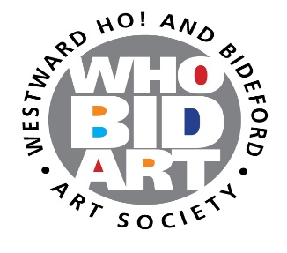
ENTRY FORM FOR THE ANNUAL EXHIBITION
PLEASE READ BOTH THE GUIDANCE NOTES AND TERMS AND THE GUIDELINES FOR PREPARATION OF ARTWORK BEFORE COMPLETING THIS FORM IN BLOCK CAPITALS

NAME: ………….. …………………………………………………………………………………………………………………………………
EMAIL: ……………………………………………………………………………………………………………………………………………..
TELEPHONE: ……………………………………………………………………………………………………………………………………………..
I AM A: FULL MEMBER/LIFE MEMBER/ASSOCIATE/NON-MEMBER
TITLE OF WORK | MEDIUM | PRICE

ENTRY FEE PAYABLE: £
BY APPLYING TO TAKE PART IN THE EXHIBITION AND SUBMITTING THIS ENTRY FORM YOU CONFIRM THAT YOU:
- HAVE READ AND UNDERSTAND THE GUIDANCE NOTES
- HAVE READ AND UNDERSTAND THE GUIDELINES FOR PRESENTATION OF ARTWORK
- AGREE THE TERMS, and
- HAVE PAID THE ENTRY FEE (IF RELEVANT)
When completed please return this form to susanbrooklynharris@gmail.com by midnight on Friday 6 March 2026

